**International University**

School of Electrical Engineering

**Principle of EE1 Laboratory**

**EE052IU**

**[Lab 3]**

**Thevenin’s Theorem**

**Submitted by**

[Đỗ Minh Duy - ITITSB22029]

[Nguyễn Đức Anh - EEACIU23005]

Date Submitted: [28/12/2024]

Date Performed: [18/11/2024]

Lab Section: [3]

Course Instructor: [Nguyen Minh Thien]

**GRADING GUIDELINE FOR LAB REPORT**

|  |  |  |  |  |
| --- | --- | --- | --- | --- |
| **Number** | **Content** |  | **Score** | **Comment** |
| 1 | **Format (max 9%)** | |  |  |
| * Font type | Yes No |  |
| * Font size | Yes No |  |
| * Lab title | Yes No |  |
| * Page number | Yes No |  |
| * Table of contents | Yes No |  |
| * Header/Footer | Yes No |  |
| * List of figures (if exists) | Yes No |  |
| * List of tables (if exists) | Yes No |  |
| * Lab report structure | Yes No |  |
| 2 | **English Grammar and Spelling (max 6%)** | |  |  |
| * Grammar | Yes No |  |
| * Spelling | Yes No |  |
| 3 | **Data and Result Analysis (max 85%)** | |  |  |
| **Total Score** | |  | |  |

Signature:

Date:

**Table of Contents**

List of Figures ............................................................................................................................3

List of Tables .................................................................................................……....................3

Nomenclature ...........................................................................................................…….….....3

Theoretical Background .............................................................................................……........4

Experimental Procedure.............................................................................................…….........4

Experimental Results ........................................................................................................….....5

Discussion of Results ...............................................................................................................11

**List of Figures**

Figure 1 –………………………….……...……………………………………………………4

Figure 2 – …………………………………………………………………..……………...…..5

Figure 3 – ……………………………………………………………………………………...5

Figure 4 –………………………………………….………………………..……………...…..6

Figure 5 – ……………………………………………………………………………………...7

Figure 6 – ……………...............................................................................................................8

Figure 7 – …………….............................................................................................................10

**List of Tables**

Table 1 – ……………………………………..……………………...........................................7

**Nomenclature**

VDD = DC Voltage Source

Vdd = AC Voltage Source

Iref = Reference Current

**Theoretical Background**

• A foundational principle in circuit analysis and electrical engineering is Thevenin's Theorem. This theorem, which bears the name of French engineer and telegrapher Leon Charles Thevenin, offers a way to make the study of complex electrical circuits easier.

• According to this theory, any linear bilateral network, no matter how complex, may be reduced to an equivalent circuit using a load resistor, a single voltage source called Thevenin voltage (Vth), and a resistance called Thevenin resistance (Rth) connected in series.

• When the load resistor is removed, the voltage at the output terminals is known as the Thevenin voltage. On the other hand, the Thevenin resistance is determined by computing the resistance between the output terminals after all independent voltage and current sources have been turned off (making independent voltage sources short-circuits and independent current sources open-circuits).

• By reducing complex circuitry to its Thevenin equivalent, engineers can use Thevenin's Theorem to study and design it. Among other things, it is especially helpful for studying integrated circuits and power systems.

**Objectives**

The aim of this lab experiment was to verify Thevenin's theorem by determining the Thevenin equivalent circuit for a given complex circuit.

**I. Experimental Procedure**

**A. Find Thevenin's equivalent circuit using short-circuit current. (Method 1)**

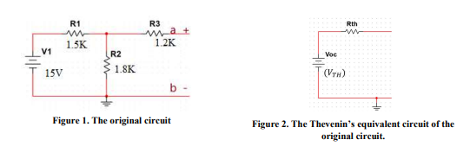

**Figure 1**

a. Using DMM, measure the open-circuit voltage (VTh = Voc) between terminals **a** and **b**.

$$\frac{Vab-15}{1500}+\frac{Vab}{1800}=0$$

Following theory, we have: Vab=Vth=8.18 V

Following measurement, we have: Vab = 8.0815 V



**Figure 2**

b. Calculate** and measure the short circuit current (Isc) of going through terminal a to terminal.

Following theory, we have: Rth = 8.1 / 0.004 = 2025 Ohm, Isc = 4 mA

Following measurement, we have: Isc = 3.591 mA



**Figure 3**

c. Calculate** the Thevenin’s Equivalent resistance using these two measured values. Use Rth = Vth / Isc for this calculation.

$$Rth= \frac{Vth}{Isc}$$

Rth = 2250 Ohm

d. Is it safe method to find Rth (in general)? If not, explain?

• Determining Thevenin resistance (Rth) using the short-circuit current approach usually comes with some dangers. In particular, a short circuit in a network with high power sources could produce high currents that can damage elements, the power source, or even start a fire.

• The particular circuit in question also affects the method's safety. The risk of a short circuit is significantly lower in the event of a low voltage circuit. However, this approach is not recommended for circuits with high voltage or power because of the possibility of hazardous current flow.

**B. Find Thevenin's equivalent circuit using variable load resistor. (Method 2)**

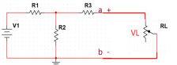

**Figure 4**

a. Using DMM, measure the open-circuit voltage (Vth=Voc) between terminals a and b.

Vth= 8.08 V

b. Insert a 10K-ohm potentiometer across the terminals a and b, as figure 4:

c. Adjust the RL until VL =1/2Vth. Carefully disconnect the potentiometer out of the circuit to measure RL correctly. This value of RL is now equal to Rth.

**Using voltage divider:**

$$VL= Vth\frac{RL}{RL+Rth}$$

then we can prove $RL=Rth$ when we know:

VL= ½ Vth

ó $\frac{1}{2} = \frac{RL}{RL+Rth}$

ó $RL= \frac{1}{2} \left(RL+Rth\right)$

ó $\frac{RL}{2}=\frac{Rth}{2}$

ó $RL=Rth$



**Figure 5**

**C. Determine maximum power transfer**

Using the circuit in Figure 3, adjust the potentiometer to complete the Table 1. Use another potentiometer if needed. Remember to disconnect the potentiometer out of the circuit every time you measure its value.

If necessary, an additional potentiometer can be employed. For this procedure, a 2000 Ohm potentiometer was used to facilitate easier measurement.

Using experimental data, the goal was to theoretically determine the value of the load resistance (RL) that enables maximum power transfer (PL) from the source to the load. According to the Maximum Power Transfer Theorem, maximum power transfer occurs when the load resistance (RL) equals the source resistance (RTh).

In this experiment, we analyzed the power transferred to different load resistances to identify the point at which maximum power was achieved.

The power across the load (PL) was calculated using the formula:

|  |  |  |  |
| --- | --- | --- | --- |
| VL | VL Measured | RL Measured | $$PL= \frac{{VL}^{2}}{RL}$$ |
| 0.3*Vth | 2.32V | 850 $Ω$ | $6.33{x10}^{-3}$ W |
| 0.4*Vth | 3.24V | 1290 $Ω$ | $8.14{x10}^{-3}$ W |
| 0.5*Vth | 4.05V | 2000 $Ω$ | $8.2{x10}^{-3}$ W |
| 0.6*Vth | 4.86V | 2970 $Ω$ | $7.953{x10}^{-3}$ W |
| 0.7*Vth | 5.67 | 4580 $Ω$ | $7.02{x10}^{-3}$ W |

**Table 1**

From the data, the maximum power delivered to the load was 8.28 mW, achieved when the load voltage (VL) was approximately half of the Thevenin voltage (0.5*Vth) and the load resistance (RL) was 2.00 kΩ. This observation is consistent with the Maximum Power Transfer Theorem, further validating its applicability in this experiment.

These results offer valuable insights into optimizing power transfer in electrical circuits. Nonetheless, it’s important to account for potential variations in practical scenarios due to factors such as component tolerances and measurement inaccuracies.

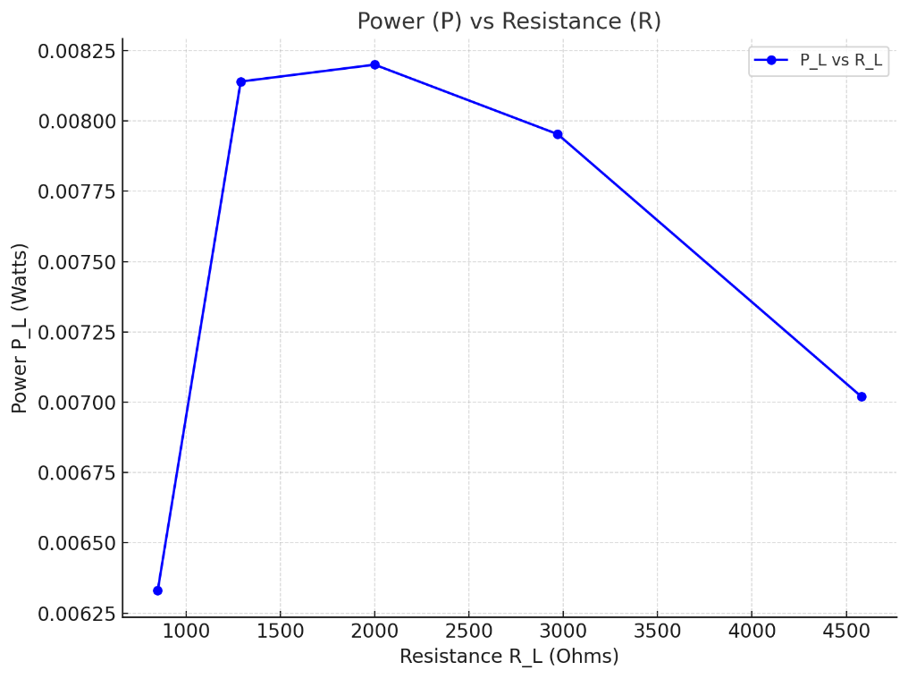

**Figure 6**

**Comments on Calculations and Measurements**

**Inverse Relationship Between Power (PL​) and Resistance (RL​)**:

**As RL​ Increases**: The data clearly shows that PL​ decreases as RL​ increases beyond the optimal point. This inverse relationship is expected, as increasing load resistance reduces the current flowing through the circuit, thereby reducing power dissipation across the load.

**As RL​ Decreases**: Similarly, PL​ increases as RL​ decreases below the optimal value. This occurs because a lower resistance allows for greater current flow, increasing power dissipation across the load.

**Optimal Relationship**:

The peak power of PL=8.28 mW occurs at RL=2.00 kΩ​, confirming the **Maximum Power Transfer Theorem**, which states that maximum power transfer occurs when RL= RS​, where RS​ is the source resistance.

This optimal point demonstrates the importance of tuning the load resistance to match the source resistance for efficient energy transfer in electrical circuits.

**Variation of PL​ With RL​**:

The variation of PL​ is not linear. While small changes in RL​ near the optimal point produce noticeable variations in PL​, larger deviations from the optimal RL​ result in smaller relative changes in power.

These variations may also be influenced by experimental factors such as the accuracy of measuring devices, component tolerances, and environmental conditions.

**Theoretical and Practical Implications**:

These experimental results align with theoretical predictions, highlighting the interplay between resistance and power in practical circuits.

However, slight discrepancies could occur due to real-world factors like parasitic resistances, temperature variations, and inaccuracies in the measuring instruments.

**Applications**:

Understanding this relationship is crucial for optimizing the performance of electrical systems, such as designing power distribution networks or maximizing efficiency in electronic devices.

These findings emphasize the need to carefully select or design circuit components to achieve optimal performance.

**Conclusion**

The experimental results confirm that power optimization in circuits requires careful adjustment of load resistance. The insights gained from this analysis provide a foundation for designing more efficient systems while highlighting potential variations due to practical limitations.

**D. APPLICATION: Thevenin Equivalent Circuit of the Function Generator**

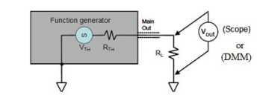

**Figure 7**

The digital multimeter (DMM) and oscilloscope were linked to the function generator. A sine wave with an amplitude of 5V was intended to be output by the function generator. The function generator was coupled to a 2kΩ potentiometer. After adjusting the potentiometer, the voltage across it (VL) was around half of the Vth (source voltage). The voltage across the potentiometer was measured and recorded using the DMM (VL). It was discovered to be roughly 2.5V.

This value was recorded as the Thevenin resistance (Rth), which was approximately 49Ω.

Vs = 5V, VL = 2.4V, Rth = 49Ω

**II. Discussion of Results**

**First method**

The open-circuit voltage (VTh = Voc) between terminals a and b will be measured in order to obtain Vab. The genuine Rth and Isc can be obtained by measuring and source-deactivating. The placement of this method is not the safest; it could short circuit and, in the worst situation, catch fire if it comes into contact with high power. This technique is limited to low-voltage circuits. For further security, you ought to employ a second method that uses a variable load resistor to evaluate Rth.

**Second method**

The experiment, which was carried out by using a variable load resistor to determine the Thevenin's equivalent circuit, produced results that are in good agreement with the theoretical predictions.   
It was successful to match the load resistance to the Thevenin’s resistance, and the measured Thevenin’s voltage and resistance matched the computed values. Thevenin's Theorem and the Maximum Power Transfer Theorem were successfully illustrated using this approach, and the experiment as a whole can be considered a success.

**The application**

Thevenin's Theorem's practical application and significance were amply illustrated in this experiment. The process and outcomes demonstrated how well it works to simplify intricate circuits and facilitate analysis. This has important ramifications in domains where working with intricate circuits is frequent, such as electrical engineering and electronics.

For example, Thevenin's theorem is frequently used in the design and testing of electronic devices like televisions, radios, and amplifiers to simplify circuits for simpler analysis and troubleshooting. This theorem is also used in power distribution networks to determine the maximum power that may be delivered to a load, which is essential for effective

**In conclusion**

In summary, this experiment demonstrated the usefulness of Thevenin's Theorem, especially in electronics and power systems, in addition to validating it. Therefore, it is essential for specialists in these domains to comprehend and utilize this theorem.